47th AEDEAN Conference Proceedings Template

AuthorA
AffiliationA
E-mailA
------
AuthorA and AuthorB
AffiliationA and AffiliationB
E-mailA, E-mailB
-----------
AuthorA, AuthorB, and AuthorC
AffiliationA, AffiliationB, and AffiliationC
E-mailA, E-mailB, E-mailC
---------------
AuthorA¹, AuthorB², and AuthorC²
¹AffiliationA, ²AffiliationBC
E-mailA, E-mailB, E-mailC

Abstract

The abstract should contain 150 words maximum. If the paper is written in Spanish, an abstract in English is mandatory. If an English translation is provided, insert one blank line between the two. Leave two blank lines between the author/affiliation section and the “Abstract/Resumen” word. Leave a blank line between the abstract and the keywords section. Leave two blank lines after the keywords section.

Keywords: keywords, are, separated, by, commas.

1. Introduction

This document is a template that will help you successfully format your paper for the 47th AEDEAN Conference Proceedings. It is a self-describing tutorial that both describes what the documents should look like and illustrates it. Please read it carefully and follow the guidelines describing the format as closely as possible. Your resulting document should look exactly like this one. Please remember that your paper must be entirely original and unpublished.
You can copy each of the elements that make up your paper, paste them in the appropriate section in this document and ask MS Word to “Match destination formatting”. Or simply replicate the format described here in your existing document. You should beware of Word’s various automatic formatting settings. They can all be disabled in the options.

1.1 Submitting your contribution (through the online application)

The file name should specify the following: AEDEAN47-PANEL-Your name. Please send it through the online application https://ebook.aedean.org/index.php?journal=conference&page=loginFiles must be exclusively Microsoft Word (.doc or .docx). You can use any other word processor of your choice, but should eventually convert it to Word’s format and check that all formatting is preserved.

1.2 Basic editing

Although your paper was peer-reviewed prior to its delivery at the 47th AEDEAN Conference, all contributions to the Proceedings should be carefully revised and edited following the guidelines of AEDEAN’s journal Atlantis. If the specifications below conflict with those in the generic Atlantis guidelines linked in the footnote above, the former override the latter.
Contributions should not exceed 3,000 words for papers (150-word abstract, notes and bibliography included) and 1,500 words for summaries of round tables and workshops.

2. Page and paragraph layout

2.1 Page setup

Top margin is 3.5 cm. Bottom 2.5 cm. Left 2.5 cm. Right 2.5 cm. All pages should be vertical (portrait). No element in the document must exceed the specified page size. No section breaks should be inserted at any point in the document.
Pages should not be numbered. The editors will do this.

2.2 Paragraph layout

Single-spacing for all paragraphs, with no blank lines left in between. Blank lines are only used to separate headings and subheadings from running text (one line before and after) and other elements such as lists and captions (see below). Before and after spacing should be 0pt for all paragraphs, no exceptions.
Section headings and subheadings must be flush left (no indenting). The first line of paragraphs must be indented 1.25 cm. The first line of the first paragraph in each section or subsection must not be indented.

3. Fonts

Times New Roman should be used exclusively. No exceptions. Paper title and level 1 headings 14pt. Footnotes and independent quotations, i.e., long quotations detached from the running text, 11pt. Everything else is 12pt.
Use italics for foreign words and phrases; emphasis or irony; examples within main text; words or terms which are the subject of discussion themselves (metalinguistic function); titles of books, journals and dissertations cited in the main text, including abbreviations (for example, OED).
Use bold typeface for the article title, headings and subheadings, and emphasis in numbered examples. Do not use bold type or any other attribute to arbitrarily highlight keywords in the running text.
Capitals: only first letters of content words in book and dissertation titles, and in names of journals. Do not use capitals for emphasis in the text.
Small capitals: only for linguistic information in examples, semantic cases, etc.

4. Punctuation

4.1 Quotation marks

If the paper is written in English, use English double quotes (“ ”), and English single quotes (‘ ’) for quotations within quotations. If the paper is written in Spanish, use Spanish double quotes (« »), and English double quotes (“ ”) for quotations within quotations.

4.2 Hyphens and dashes

Hyphens should be used to combine words, as in He was given a good talking-to. N-dashes, for ranges of dates and figures, as in “Jones (1999: 50–60)” or “Visser (1963–1973)”. In Word, press Ctrl + the minus sign on the numeric keypad at the same time. M-dashes—if you really have to use them—should only contain parenthetical comments, as an alternative to brackets or commas. In Word, press Ctrl + Alt + the minus sign on the numeric keypad at the same time.

4.3 Order of punctuation marks

If the whole sentence goes inside brackets, the period is placed inside. (Remember this.) If the bracket is at the end of a sentence but inside a sentence, the period is placed outside (like this).

4.4 Others

In-line spaces. Leave only one blank space after stops and colons (no double spacing). Before you send us your paper, please run the Search and Replace function in Word to check this.
Colors. Do not use any colors in your text, unless it is absolutely necessary. Color images are allowed, though (see section 6 below).

5. Section headings and subheadings

Level 1 headings are 14pt in size, the rest are 12pt. All bold typeface. All are preceded and followed by a blank line. The Abstract and References sections are 12pt and not numbered.
Do not use MS Word’s automatic multi-level numbering system. Type in your own numbers and format them manually. Disable, if necessary, this feature in Word’s options.
The numbering of level one headings should end with a period.

5.1 This is an example of level 2 subheading

5.1.1 This is an example of level 3 subheading

A blank line is always left before and after each subheading, even if there is no text between them, even if the subheading is at the top of the page. Do not go beyond level 3. A period is not used to end the line in headings.

6. Graphics and tables

Graphics and tables should be inserted in their original places. Make sure that image size is reasonable. There will be no printed version of these Proceedings, so it is not necessary to use high-resolution graphics. If the resulting size of your document is over 1 MB, your graphics’ resolution may have to be scaled down.
Figure 1 below is an example of an inserted picture.

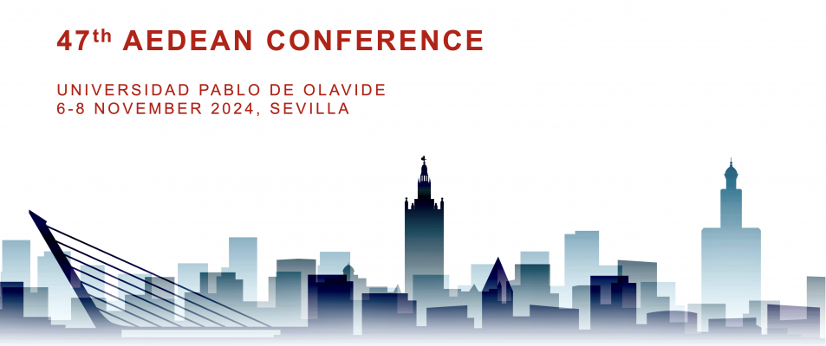
Figure 1: Example of inserted picture

Inserted graphics and tables should be preceded and followed by a blank line, centered on page, and a centered caption (11pt size) should be added below. They should also be numbered for in-text referencing. It is up to you whether you keep the original colors or use gray scale, but bear in mind file size concerns.
Tables have their own numbering, are also centered and need a caption. Table 1 below is an example.
Table text is 11pt. Keep style simple: single lines, no shading, and no colors. Refrain from using fancy styles. Use tables to make structured data more readable, not just to add arguably attractive elements to your text.
Avoid using large tables horizontally: you can split them in two tables if necessary. Avoid MS Word’s default to take up the entire width of the page. You can do this by selecting a desired column width in the “Initial column width” option. Make all columns the same width if possible.

 | Col head1 | Col head2 | Col head3 | Col head4
Row head1
Row head2
Row head3
Row head4
Table 1: Example of table

Whenever possible, try to avoid splitting tables across pages, but do not force too many blank lines for this. A split table is preferable. Try changing the location of the table, or its size.
The alignment of content within cells is up to you. However, it is good practice to center column headings and left-align row headings.

7. Lists

Before adding a list to your document ask yourself whether it is really necessary or if it will make your text more readable. Keep lists to a minimum.
Lists are numbered when the number or order of items is relevant, or when you will be making reference to them in the text. Unnumbered lists are used in the rest of the cases.

- This is an example of a numbered list
- Arabic numerals are used.
- Indenting is Word’s default. Text starts at 1.25 cm, flush with the rest of the paragraphs.
  - This is a nested list.
  - We use lower case letters.
    - Do not go beyond level two nesting unless it is absolutely necessary.
    - If you do, use lower case roman numerals.
- Use periods after each list item.
- Start each item with a capital letter.

A blank line is inserted before and after each list.

- This is an example of an unordered list.
- We use simple black bullets, i.e., MS Word’s default.
  - This is a nested unordered list.
  - White bullets are used.
  - Do not go beyond level 2 nesting.
- Bullet points should be concise. A bullet point should never go beyond the paragraph level.
- Please, do not overdo lists!

8. Examples, notes, and quotations

8.1 Examples

Examples should be numbered with Arabic numerals in parentheses. Use the same font and font size as the text of the paper (TNR 12pt). Use small capitals for linguistic information in the examples. Use italics for translations of examples.
Leave a blank line before and after the examples. In order to keep the alignment, you may use a table, as in the following example:

(1) | Pater | amat | fillam.
(2) | Patrem | amat | filla.
(3) | Pater | amat | fillam.
 | Father nom | loves pres | daughter acc
 | The father | loves | the daughter.

8.2 Notes

Notes should be kept to a minimum and not be used to provide references. They should be sent as footnotes. All footnotes must be numbered consecutively for the whole paper in Arabic numerals.
It is preferable to place them at the end of sentences, after the stop, not in the middle of the sentence.

8.3 Quotations

Appropriate reference to the source should be given for in-text and independent quotations.

Quotations longer than three lines should be written in an independent paragraph, indented both left and right (1.25 cm), without quotation marks, font size 11. Quotations longer than three lines should be written in an independent paragraph, indented both left and right (1.25 cm), without quotation marks, font size 11.

A blank line is left before and after independent quotations.

9. Final remarks

When you are done formatting, it is a good idea to print out both this document and your own, and perform a final visual check side by side. Play spot-the-difference!

References

Use the Atlantis guidelines for references and in-text citations (see footnote 2).

Do not use Word’s automatic conversion of e-mail addresses into hyperlinks. After Word’s automatic conversion (if turned on), right-click on link and select “Hyperlink – Edit hyperlink”, then click the “Remove hyperlink” button. Bold typeface has been added here for emphasis. Do not use it in your document.
Check them at http://www.atlantisjournal.org/index.php/atlantis/about/submissions#authorGuidelines. As this example suggests, it is good practice to include web addresses in footnotes rather than in the running text. Also, do keep automatic hyperlinks for web addresses in order to provide a more integrated e-book experience.
The equivalent key to Ctrl in a Mac OS X system is Command (found on both sides of the space bar).

